**Paper 1.** [Link](https://ceur-ws.org/Vol-3130/paper8.pdf)

**github:** [link](https://github.com/F-U-Njoku/filter-fs-impact-on-classification)

**Title:** Impact of ﬁlter feature selection on classiﬁcation: an empirical study

**Summary:** 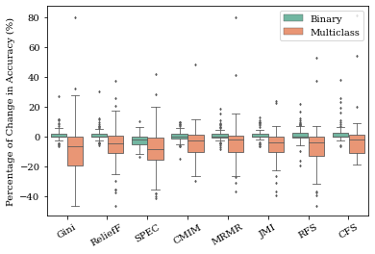Datasets nowadays contain redundant or irrelevant information. To identify the most relevant part of a dataset, we use feature selection. There are numerous feature selection methods that do not rely on machine learning algorithms to function, they are called filter methods. However, when is it appropriate to use each of these methods? Based on extensive experiments, we show the impacts of filter feature selection on classification. We also analyse the time complexity of these methods and a guideline for their use.

→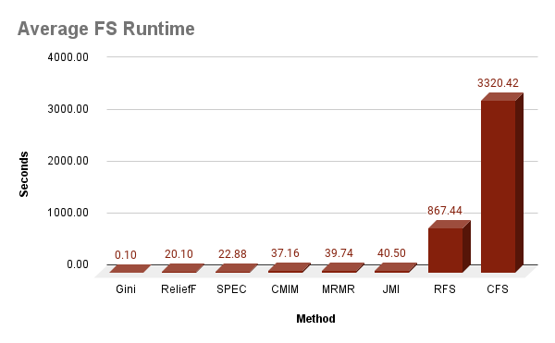Filter methods are better for binary classification.

→Gini is the most time efficient while CFS is the least.

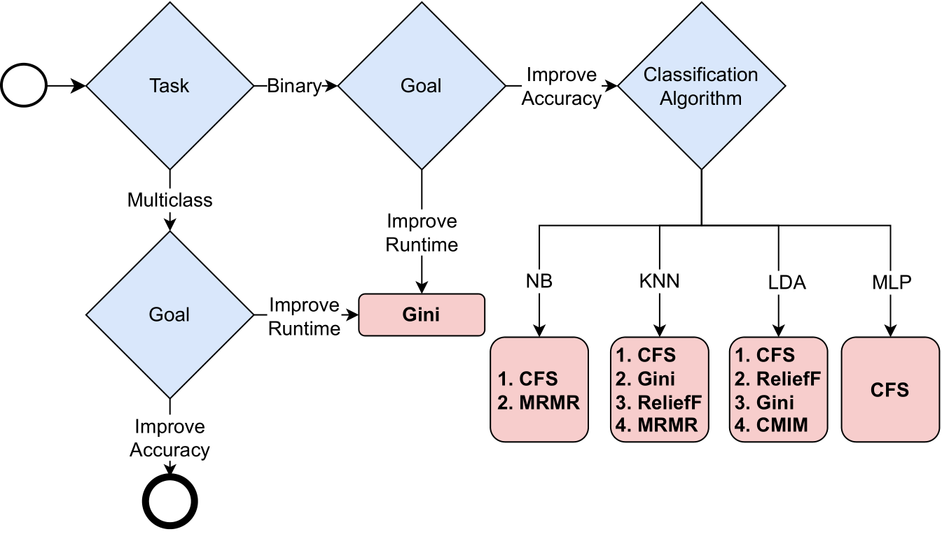

→Guideline for use according to our experiment results.

**Paper 2.** [Link](https://openproceedings.org/2023/conf/edbt/3-paper-109.pdf)  
**github:** [link](https://github.com/F-U-Njoku/Wrapper-Methods-in-Multi-Objective-Feature-Selection)

**Title:** Wrapper Methods for Multi-Objective Feature Selection

**Summary:** Wrapper feature selection methods use machine learning algorithms to find the relevant information (features) in a given dataset. However, they have the drawback of high time complexity. In this work, we extensively experiment with the wrapper feature selection method -SFS, comparing it to filter methods. The results of our extensive experiments shows the superiority of wrapper methods over filter methods in model performance (accuracy). We further investigate the role of wrapper methods in multi-objective feature selection with a focus on two traditional metrics - accuracy and Area Under the ROC Curve (AUC). Lastly, our results show time complexity of the methods grows faster with an increasing number of features than the number of instances.

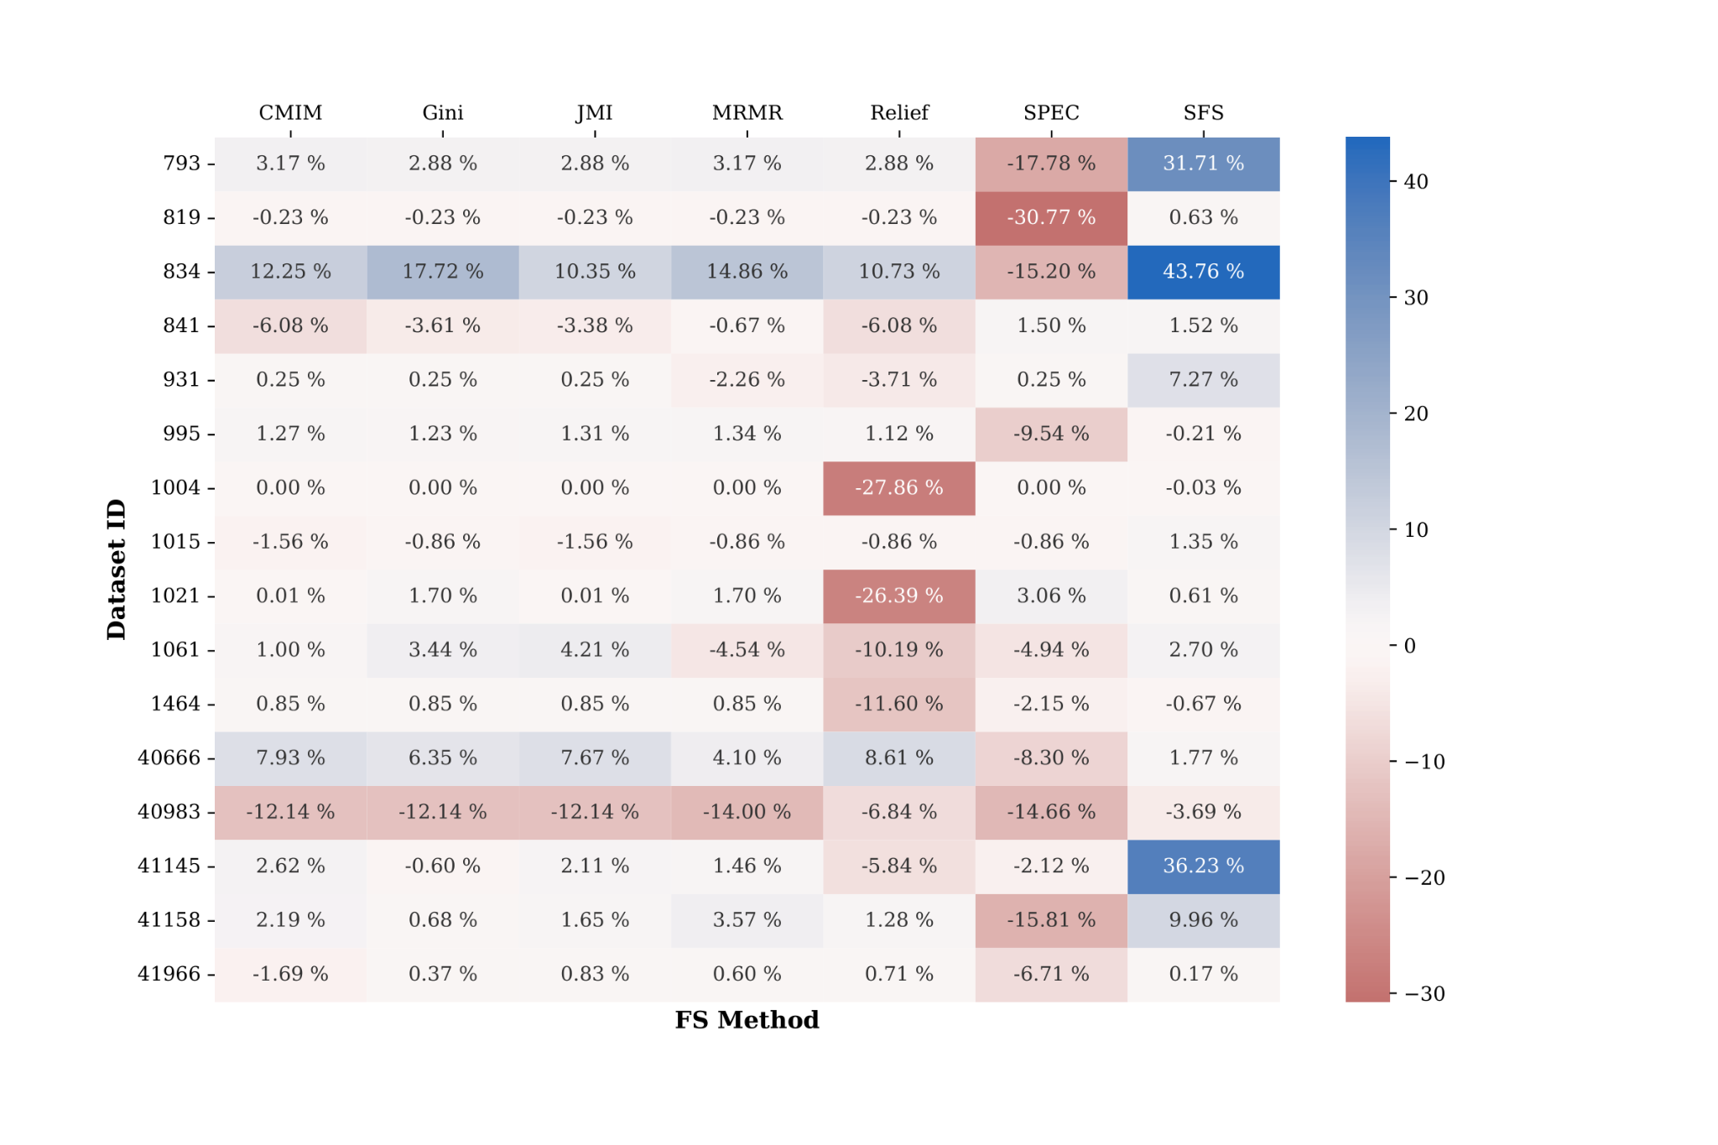

→Change in accuracy better in wrapper method (SFS)

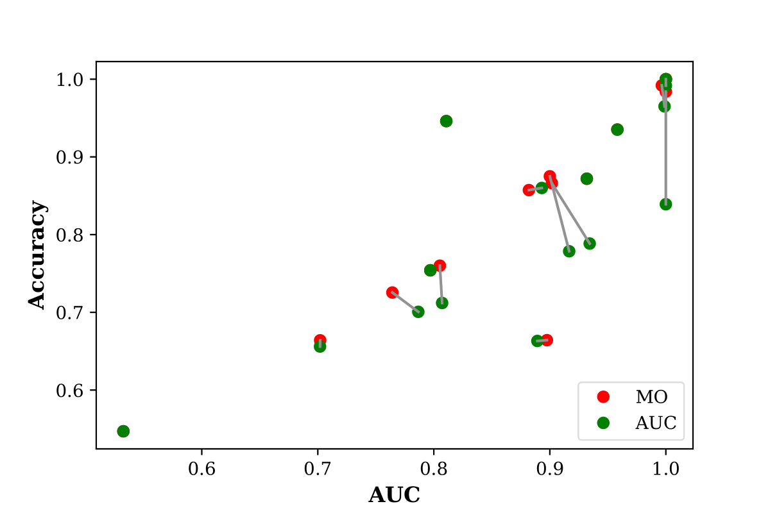

→There is an increase in accuracy when it is combined with a second metric (MO/red) compared to when it is not taken into account at all (AUC/green).

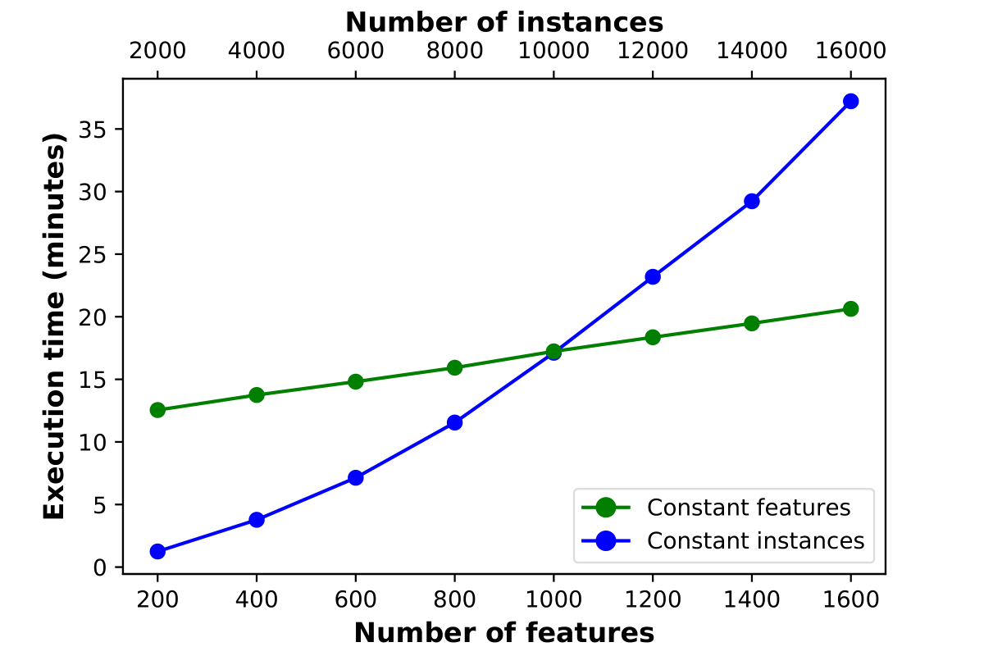

→Time complexity of the methods grows faster with an increasing number of features

**Personal Profile**

Uchechukwu Njoku obtained her bachelor's degree in computer science and mathematics from the University of Nigeria, Nsukka in 2014. After graduating, she gained interest in machine learning and furthered her education by obtaining a masters in computer science in 2019 from the African University of Science and Technology, Abuja funded by the African development bank. In her thesis, she focused on using topic modelling to detect hot topics on health related issues in Nigeria from Twitter. In 2019, she was one of the recipients of the Erasmus Mundus scholarship for the joint European masters in Big Data Management and Analytics masters. She researched the impact of feature selection on classification in her thesis. In 2021, she began her career as an early stage researcher focused on the optimization of feature selection for big data. Her research is a joint collaboration between Universitat Politècnica de Catalunya, Université Libre de Bruxelles, and Orange Belgium as an industrial partner. The research is funded by the European Commission under the European Union’s Horizon 2020 research and innovation programme.